Strawberry Creek DeCal Discussion 4/22/2014
Communicating the Need for Restoration
By Jen Podvin

What is a weed?
- A plant out of place
- A plant that interferes with the management objectives at any given time or place.
- Plants that inhibit the efficient use of natural resources.
- More?

What is an invasive species?
-A non-native species whose introduction is likely to cause economic, environmental harm or harm to human health (National Invasive Species Management Plan 2008-2012).

Why should we care?
- Stimulated by the global expansion of trade, transport, and travel—invasive species and their cost to society are increasing at an alarming rate.
Some statistics:
- Globally—the damage caused by invasive species is estimated at $1.4 trillion or about 5% of the global economy (Pimentel et al. 2001).
- In the U.S.—invasive and exotic weeds are estimated to cost about $2.7 billion per year from crop losses, loss of pasture, and costs of pesticides and other controls and invasives are in part responsible for about 42 % of endangered species (Pimentel 2005).
- Non-natives do not support native pollinators as well as native plants—an economic loss of about $1-2.5 billion per year (Chaplin et al. 2010).

What is Biodiversity?

Some definitions:
-- “Biodiversity is the total variety of life on earth. It includes all genes, species and ecosystems and the ecological processes of which they are a part” (U.N. Convention on Biodiversity 1992)

--“Biodiversity: The variety of organisms considered at all levels… includes the variety of ecosystems, which comprise both the communities of organisms within particular habitats and the physical conditions under which they live” (E. O. Wilson 1992).

Biodiversity is the combination of two terms:
Biological- living units and the interactions between them and their environment
AND
Diversity- the total number of species and how they are represented (richness, evenness and similarity).

**Considered on many scales from allelesgenesindividualspopulations speciescommunitieshabitats ecosystems biomesbiosphere (planet Earth)**

Some basic assumptions that conservation biologists make about biodiversity:
- Diversity is good.
- Untimely extinction of a species is bad.
- Ecological complexity is good.
- Evolution is good.
- Biological diversity has intrinsic value.
Question 1: Why do you think this is so or not so?

Measuring Biodiversity:
Species richness- refers the # of different species present in a defined area (ecosystem or landscape)
Species evenness- refers to the relative abundance of different species present.
Similarity- refers to the comparison of species richness (or #) between two distinct communities.

For example:

 | Numbers of individuals
Flower Species | Sample 1 | Sample 2
Daisy | 300 | 20
Dandelion | 335 | 49
Buttercup | 365 | 931
Total | 1000 | 1000

A community dominated by one or two species is considered to be less diverse than one in which several different species have a similar abundance. As species richness and evenness increase, so diversity increases.
Question 2: Which of the 2 samples from above is more diverse?

Structural diversity- looks at community structure. For example, in a healthy forest, one should find ground cover, an understory, and a canopy layer

Functional diversity- measures ecosystem functions such as predators, keystone species, etc; it can also take into account ecosystem services such as water purification or flood protection.

Why conserve biodiversity?
Question 3: Three approaches: which reason is most compelling to you and why?

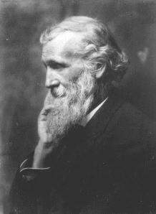
Intrinsic value (John Muir)
– All species have value independently of their utility to humans

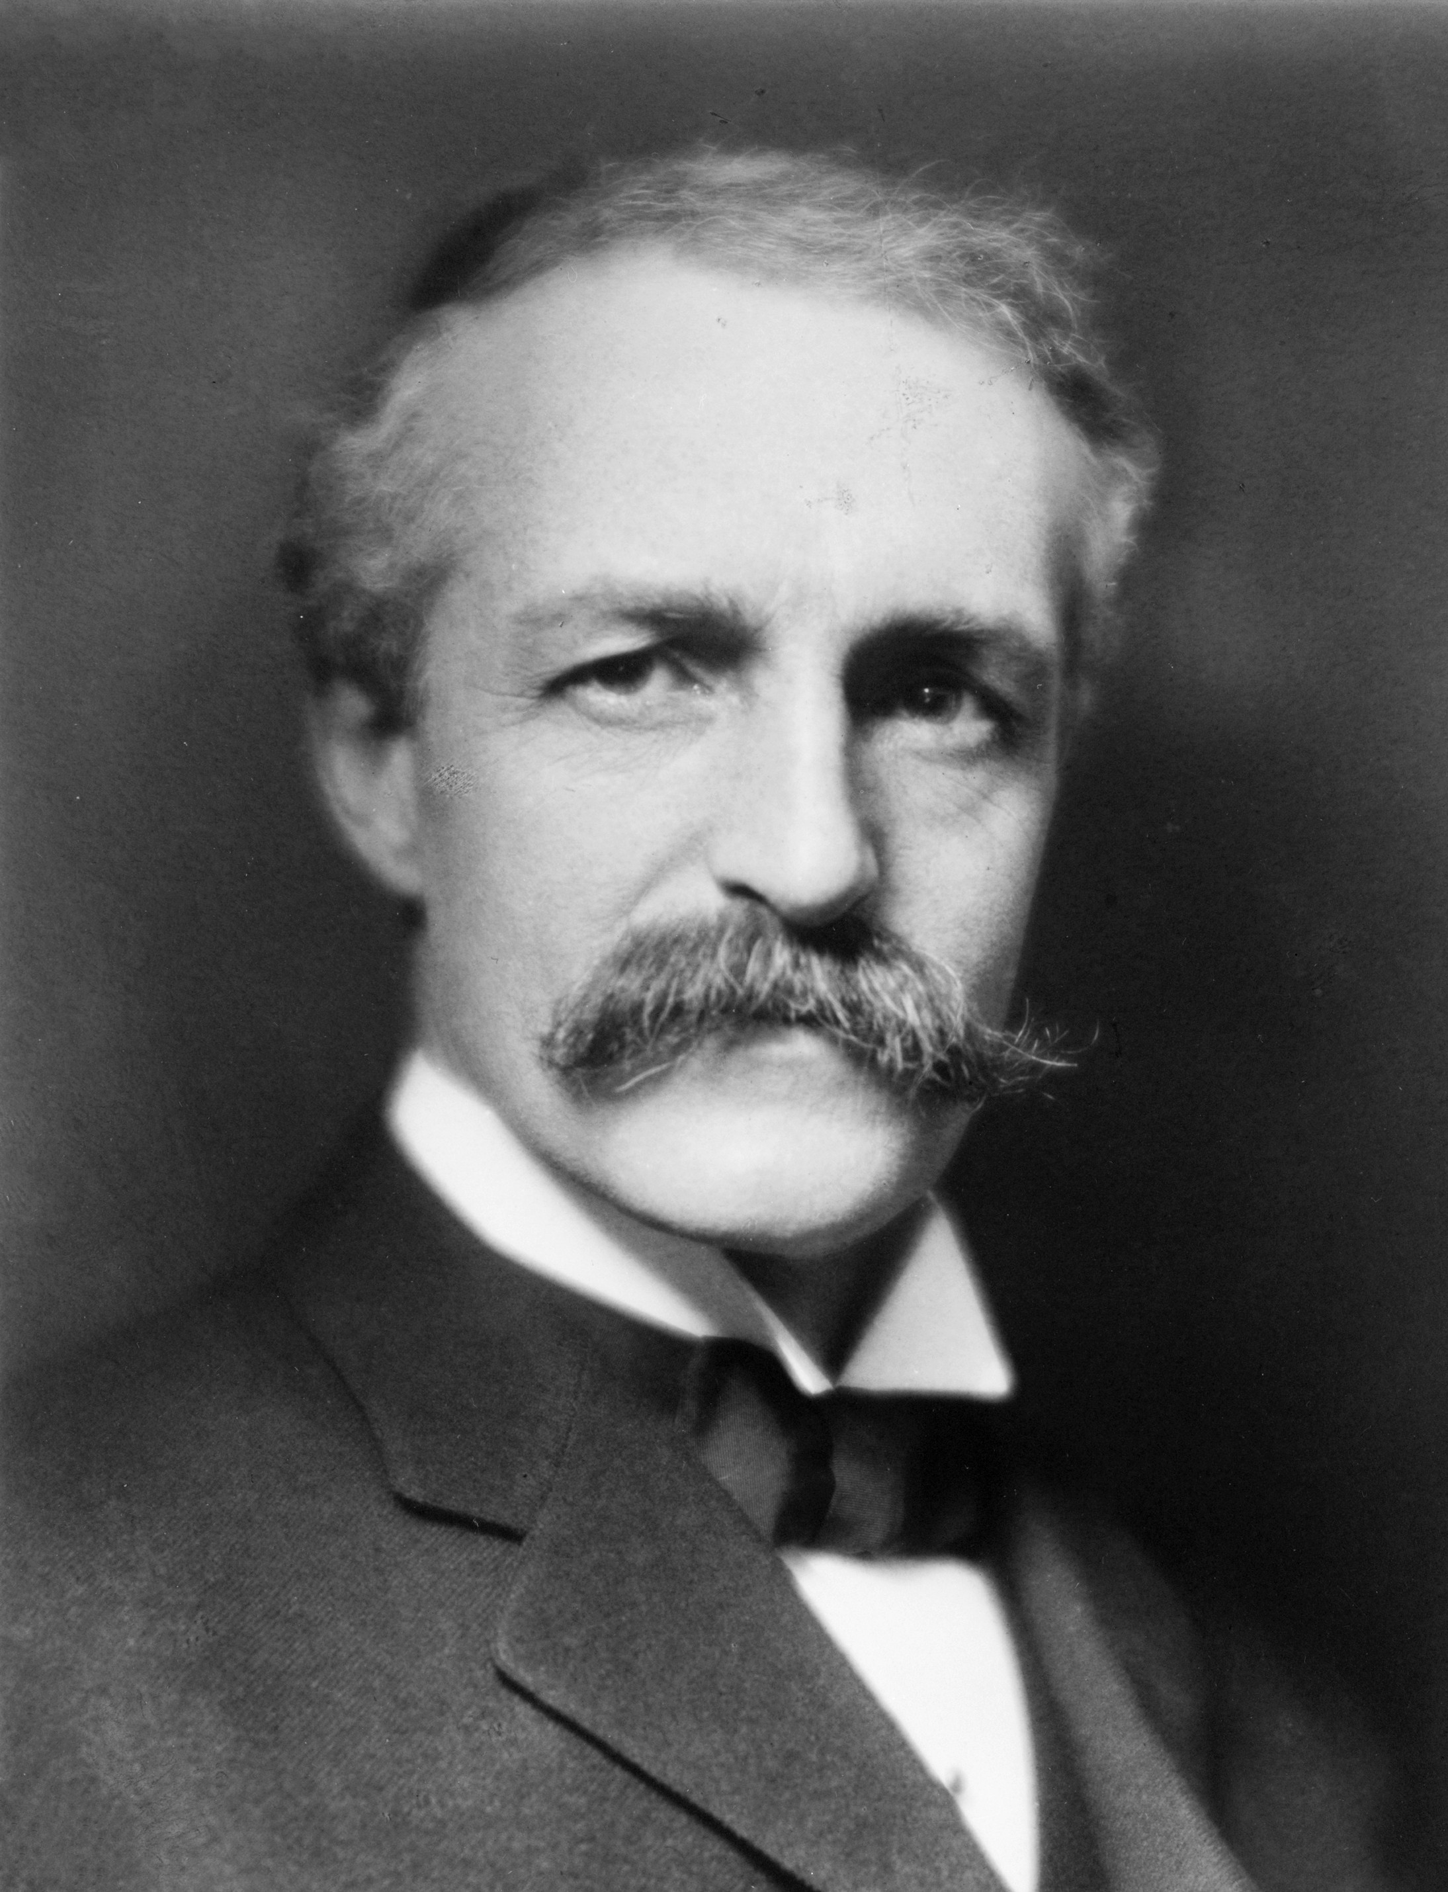

Utilitarian value (Gifford Pinchot)
– Species that provide the “greatest good to the greatest number” (over the longest time) have value.

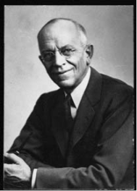
Synthetic Approach (Aldo Leopold)
-- Species have both intrinsic and utilitarian values-- Humans are part of the system

